Welcome!
Date
Name
Spouse
Address
City
State Zip _________
Email

Please Contact By
❑ Card  Phone  Visit

Telephone Best Time to Call
Home ______________
Work ______________

Guest: First Time Second Time
Are you a church member: yes no
Church
City, State

Circle Appropriate Age/Grade Group(s)
Preschool: Ages: B-1 2-3 4-5
Children: Grades: K 1 2 3 4 5 6
Youth: Grades: 7 8 9 10 11 12
Adults: Ages:18-29 30s 40s 50s 60s+

How did you learn about our church?
Newspaper Friend Yellow Pages Mail
Other

I am a guest of:

New in the Community? Yes No
Names & ages of children at home

Weekly Service & Activity Schedule

Feb 25, 2018
9:45 a.m. Sunday School
11:00 a.m. Worship Service
6:00 p.m. Evening Service

Week of Feb 25, 2018

Wednesday 6:30 pm……………..……….Meal/Bible Study
Friday 6:30 pm……………….…………..Men’s 42 Night
March
4…………………………..….New Commandment Kids
11…………………………….New Commandment Kids
11………………………………………Business Meeting
4 – 11…..Wk of Prayer for Annie Armstrong Missions

Join us for lunch after the worship service as we celebrate Valentine’s Day. See if you can match the childhood pictures with the adult.


FEBRUARY

Each month we will collect different items for Operation Christmas Child. Accessories include sunglasses, jewelry, watches, hair bows, etc.

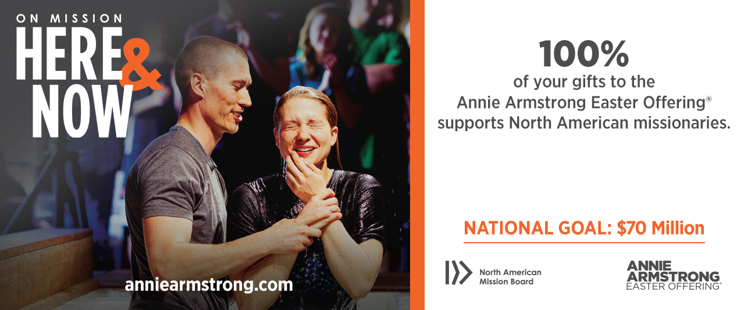

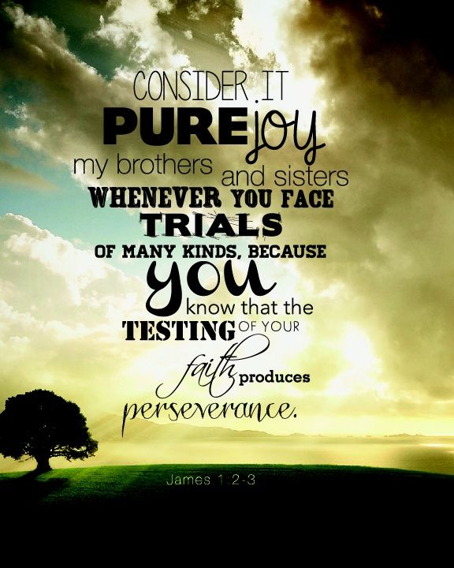

Knobbs Springs Baptist Church

Feb 25, 2018

Church Information:

KnobbsSpringsBC.com KnobbsSpringsBaptist@gmail.com

1662 CR 305, McDade, Texas 78650 512-273-2743

David Atwood, Pastor Cell 512-470-5098

Patti Radford, Office Manager Cell 512-968-7821

